**Experiment 4**

**List out the required processes to be coded along with the required flow charts.**

**1- Registration**

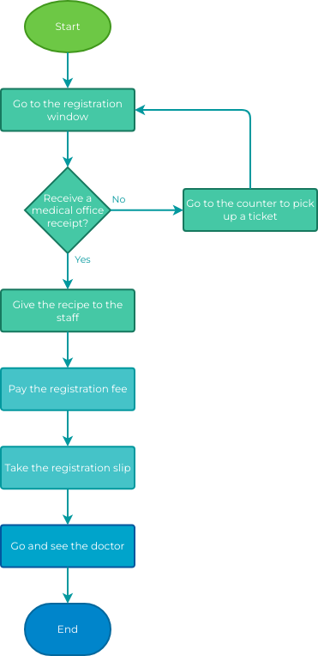

**Login**

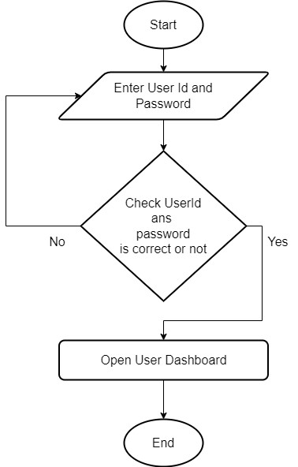

**Filling Form**

